|  |  |  |
| --- | --- | --- |
| **Design plan: Store Desktop Application** | **Document Name: Process Design Document** | **SWD/Form No.7** |
| **Effective Date: 3/22/2017** | **Version: 1** | **Page No.1/15** |

**DFD Context Diagram**

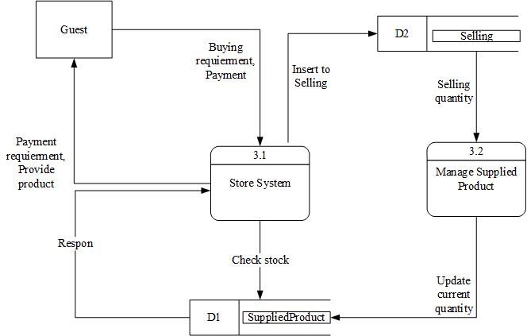

|  |  |  |
| --- | --- | --- |
|  | **Prepared By (Student)** | **Approved By (Teacher)** |
| **Date: 3/22/2017** | **Nguyen Phuoc Nguyen** | **Luong The Anh** |

|  |  |  |
| --- | --- | --- |
| **Design plan: Store Desktop Application** | **Document Name: Process Design Document** | **SWD/Form No.7** |
| **Effective Date: 3/22/2017** | **Version: 1** | **Page No. 2/15** |

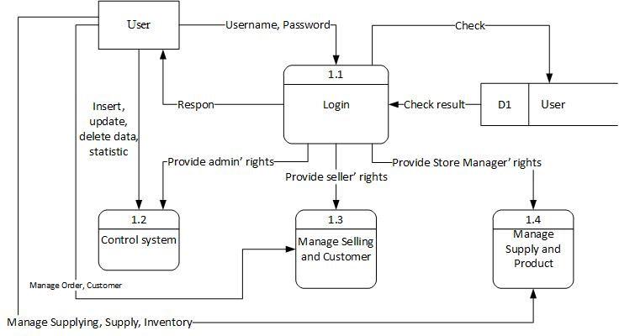

|  |  |  |
| --- | --- | --- |
|  | **Prepared By (Student)** | **Approved By (Teacher)** |
| **Date: 3/22/2017** | **Nguyen Phuoc Nguyen** | **Luong The Anh** |

|  |  |  |
| --- | --- | --- |
| **Design plan: Store Desktop Application** | **Document Name: Process Design Document** | **SWD/Form No.7** |
| **Effective Date: 3/22/2017** | **Version: 1** | **Page No.3/15** |



|  |  |  |
| --- | --- | --- |
|  | **Prepared By (Student)** | **Approved By (Teacher)** |
| **Date: 3/22/2017** | **Nguyen Phuoc Nguyen** | **Luong The Anh** |

|  |  |  |
| --- | --- | --- |
| **Design plan: Store Desktop Application** | **Document Name: Process Design Document** | **SWD/Form No.7** |
| **Effective Date: 3/22/2017** | **Version: 1** | **Page No.4/15** |

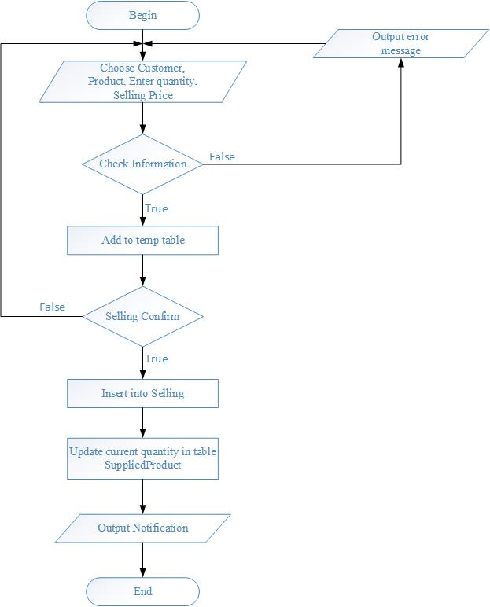**Selling (Retail)**

|  |  |  |
| --- | --- | --- |
|  | **Prepared By (Student)** | **Approved By (Teacher)** |
| **Date: 3/22/2017** | **Nguyen Phuoc Nguyen** | **Luong The Anh** |

|  |  |  |
| --- | --- | --- |
| **Design plan: Store Desktop Application** | **Document Name: Process Design Document** | **SWD/Form No.7** |
| **Effective Date: 3/22/2017** | **Version: 1** | **Page No.5/15** |

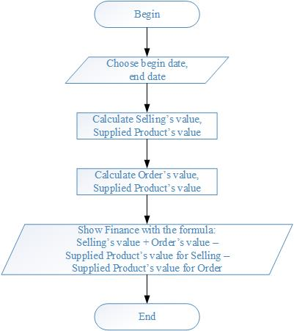**Statistic**

|  |  |  |
| --- | --- | --- |
|  | **Prepared By (Student)** | **Approved By (Teacher)** |
| **Date: 3/22/2017** | **Nguyen Phuoc Nguyen** | **Luong The Anh** |

|  |  |  |
| --- | --- | --- |
| **Design plan: Store Desktop Application** | **Document Name: Process Design Document** | **SWD/Form No.7** |
| **Effective Date: 3/22/2017** | **Version: 1** | **Page No.6/15** |

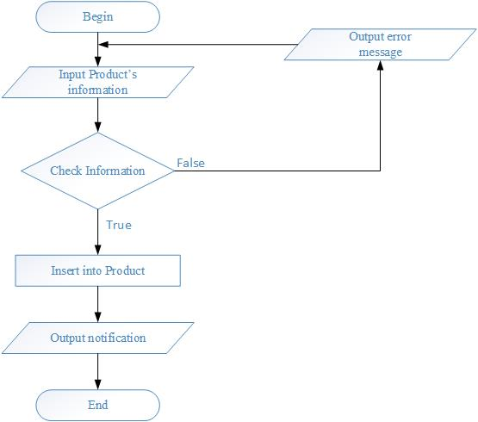**New Product**

|  |  |  |
| --- | --- | --- |
|  | **Prepared By (Student)** | **Approved By (Teacher)** |
| **Date: 3/22/2017** | **Nguyen Phuoc Nguyen** | **Luong The Anh** |

|  |  |  |
| --- | --- | --- |
| **Design plan: Store Desktop Application** | **Document Name: Process Design Document** | **SWD/Form No.7** |
| **Effective Date: 3/22/2017** | **Version: 1** | **Page No.7/15** |

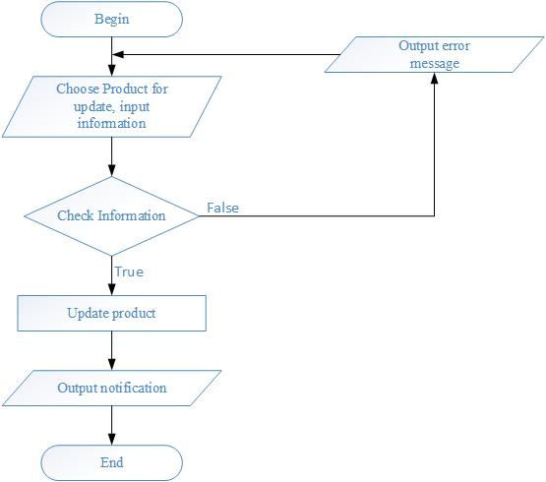**Update Product**

|  |  |  |
| --- | --- | --- |
|  | **Prepared By (Student)** | **Approved By (Teacher)** |
| **Date: 3/22/2017** | **Nguyen Phuoc Nguyen** | **Luong The Anh** |

|  |  |  |
| --- | --- | --- |
| **Design plan: Store Desktop Application** | **Document Name: Process Design Document** | **SWD/Form No.7** |
| **Effective Date: 3/22/2017** | **Version: 1** | **Page No.8/15** |

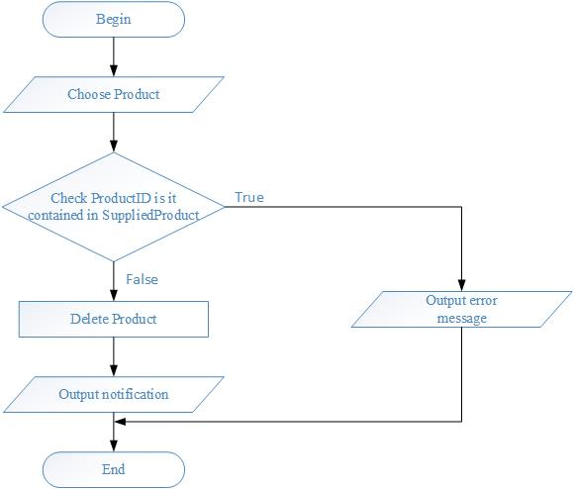**Delete Product**

|  |  |  |
| --- | --- | --- |
|  | **Prepared By (Student)** | **Approved By (Teacher)** |
| **Date: 3/22/2017** | **Nguyen Phuoc Nguyen** | **Luong The Anh** |

|  |  |  |
| --- | --- | --- |
| **Design plan: Store Desktop Application** | **Document Name: Process Design Document** | **SWD/Form No.7** |
| **Effective Date: 3/22/2017** | **Version: 1** | **Page No.9/15** |

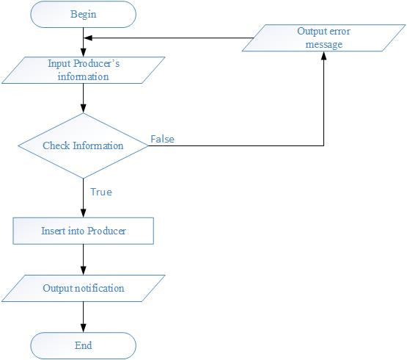**New Producer**

|  |  |  |
| --- | --- | --- |
|  | **Prepared By (Student)** | **Approved By (Teacher)** |
| **Date: 3/22/2017** | **Nguyen Phuoc Nguyen** | **Luong The Anh** |

|  |  |  |
| --- | --- | --- |
| **Design plan: Store Desktop Application** | **Document Name: Process Design Document** | **SWD/Form No.7** |
| **Effective Date: 3/22/2017** | **Version: 1** | **Page No.10/15** |

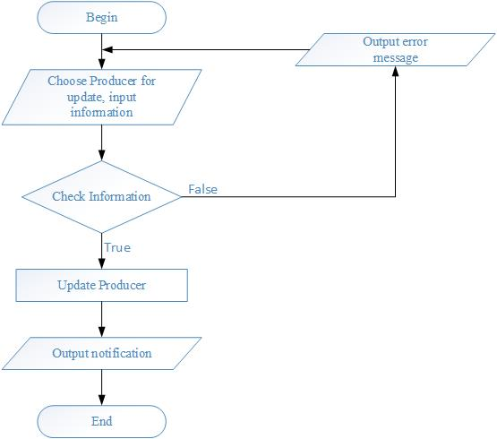**Update Producer**

|  |  |  |
| --- | --- | --- |
|  | **Prepared By (Student)** | **Approved By (Teacher)** |
| **Date: 3/22/2017** | **Nguyen Phuoc Nguyen** | **Luong The Anh** |

|  |  |  |
| --- | --- | --- |
| **Design plan: Store Desktop Application** | **Document Name: Process Design Document** | **SWD/Form No.7** |
| **Effective Date: 3/22/2017** | **Version: 1** | **Page No.11/15** |

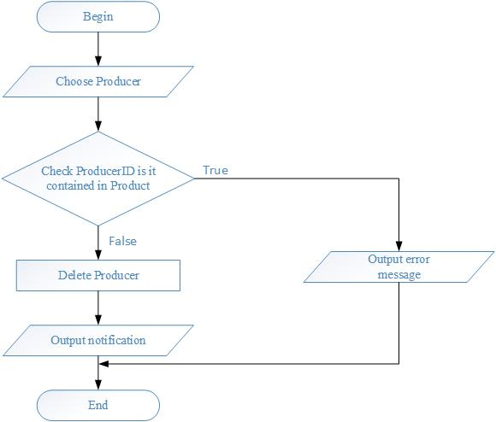**Delete Producer**

|  |  |  |
| --- | --- | --- |
|  | **Prepared By (Student)** | **Approved By (Teacher)** |
| **Date: 3/22/2017** | **Nguyen Phuoc Nguyen** | **Luong The Anh** |

|  |  |  |
| --- | --- | --- |
| **Design plan: Store Desktop Application** | **Document Name: Process Design Document** | **SWD/Form No.7** |
| **Effective Date: 3/22/2017** | **Version: 1** | **Page No.12/15** |

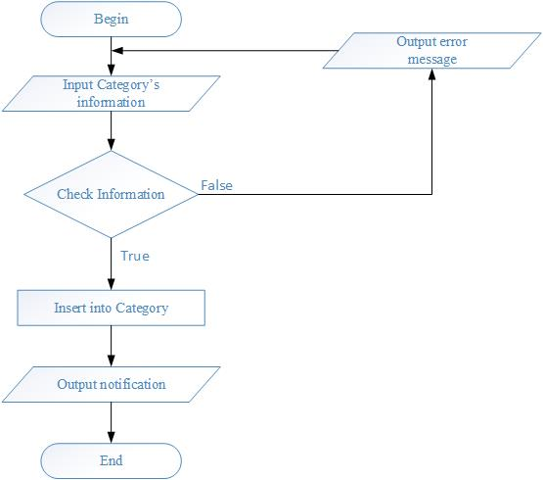**New Category**

|  |  |  |
| --- | --- | --- |
|  | **Prepared By (Student)** | **Approved By (Teacher)** |
| **Date: 3/22/2017** | **Nguyen Phuoc Nguyen** | **Luong The Anh** |

|  |  |  |
| --- | --- | --- |
| **Design plan: Store Desktop Application** | **Document Name: Process Design Document** | **SWD/Form No.7** |
| **Effective Date: 3/22/2017** | **Version: 1** | **Page No.13/15** |

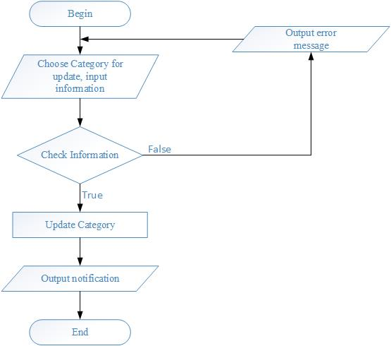**Update Category**

|  |  |  |
| --- | --- | --- |
|  | **Prepared By (Student)** | **Approved By (Teacher)** |
| **Date: 3/22/2017** | **Nguyen Phuoc Nguyen** | **Luong The Anh** |

|  |  |  |
| --- | --- | --- |
| **Design plan: Store Desktop Application** | **Document Name: Process Design Document** | **SWD/Form No.7** |
| **Effective Date: 3/22/2017** | **Version: 1** | **Page No.14/15** |

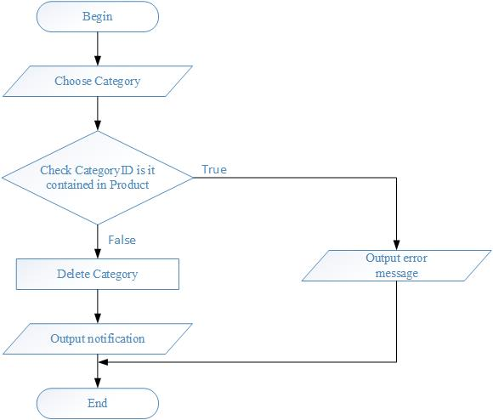**Delete Category**

|  |  |  |
| --- | --- | --- |
|  | **Prepared By (Student)** | **Approved By (Teacher)** |
| **Date: 3/22/2017** | **Nguyen Phuoc Nguyen** | **Luong The Anh** |

|  |  |  |
| --- | --- | --- |
| **Design plan: Store Desktop Application** | **Document Name: Process Design Document** | **SWD/Form No.7** |
| **Effective Date: 3/22/2017** | **Version: 1** | **Page No.15/15** |

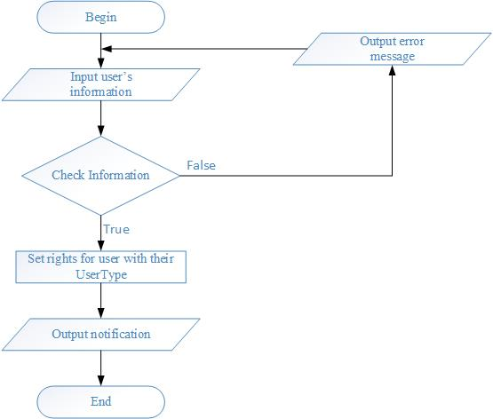**User Login**

|  |  |  |
| --- | --- | --- |
|  | **Prepared By (Student)** | **Approved By (Teacher)** |
| **Date: 3/22/2017** | **Nguyen Phuoc Nguyen** | **Luong The Anh** |